Experiment 1: Simple Calculator Using Python
1. Aim
To write a Python program to perform basic arithmetic operations using a simple calculator.
2. Algorithm
- Start the program.
- Get two numbers from the user.
- Display the arithmetic operations: addition, subtraction, multiplication, and division.
- Get the user's choice of operation.
- Perform the selected operation and display the result. Handle division by zero.
- Stop the program.
3. Program:
# Simple Calculator
num1 = 20
num2 = 10
choice = 1
print("First number:", num1)
print("Second number:", num2)
print("1. Addition")
print("2. Subtraction")
print("3. Multiplication")
print("4. Division")
print("Choice:", choice)
if choice == 1:
print("Result:", num1 + num2)
elif choice == 2:
print("Result:", num1 - num2)
elif choice == 3:
print("Result:", num1 * num2)
elif choice == 4:
if num2 != 0:
print("Result:", num1 / num2)
else:
print("Division by zero is not allowed")
else:
print("Invalid choice")
4.Output
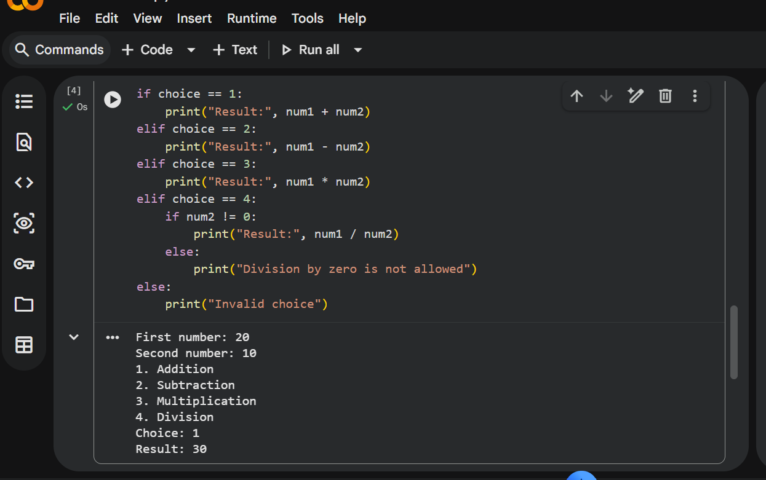
5. Result
Thus, the Python program to implement a simple calculator performing addition, subtraction, multiplication, and division was executed successfully.

Experiment 2: Addition of Two Matrices Using Python
1. Aim
To write a Python program to add two matrices.
2. Algorithm
- Start the program.
- Initialize two matrices of the same size.
- Create an empty result matrix.
- Add the corresponding elements of both matrices.
- Display the resultant matrix.
- Stop the program.
3. Program:
# Addition of Two Matrices
A = [[1, 2, 3],
[4, 5, 6],
[7, 8, 9]]
B = [[9, 8, 7],
[6, 5, 4],
[3, 2, 1]]
result = [[0, 0, 0],
[0, 0, 0],
[0, 0, 0]]
for i in range(3):
for j in range(3):
result[i][j] = A[i][j] + B[i][j]
print("Matrix A:")
for row in A:
print(row)
print("Matrix B:")
for row in B:
print(row)
print("Addition of Two Matrices:")
for row in result:
print(row)
4.Output:
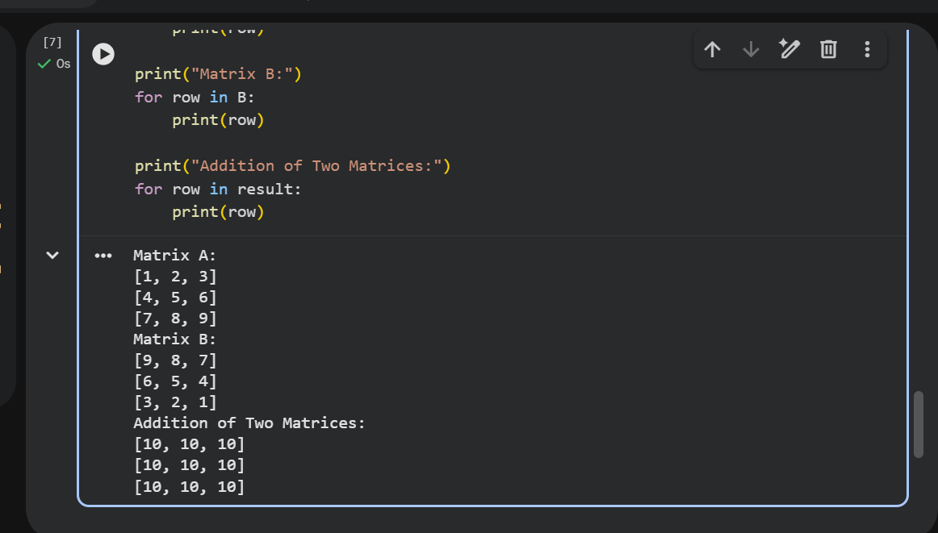

5. Result
Thus, the Python program to add two matrices was executed successfully.

Experiment 3: Transpose of a Matrix Using Python
1. Aim
To write a Python program to find the transpose of a matrix.
2. Algorithm
- Start the program.
- Initialize a matrix.
- Create an empty matrix for the transpose.
- Exchange the rows and columns of the original matrix.
- Display the original matrix and its transpose.
- Stop the program.
3.Program
# Transpose of a Matrix
A = [[1, 2, 3],
[4, 5, 6],
[7, 8, 9]]
rows = len(A)
cols = len(A[0])
transpose = [[0 for i in range(rows)] for j in range(cols)]
for i in range(rows):
for j in range(cols):
transpose[j][i] = A[i][j
print("Original Matrix:")
for row in A:
print(row)
print("Transpose of Matrix:")
for row in transpose:
print(row)

4.Output
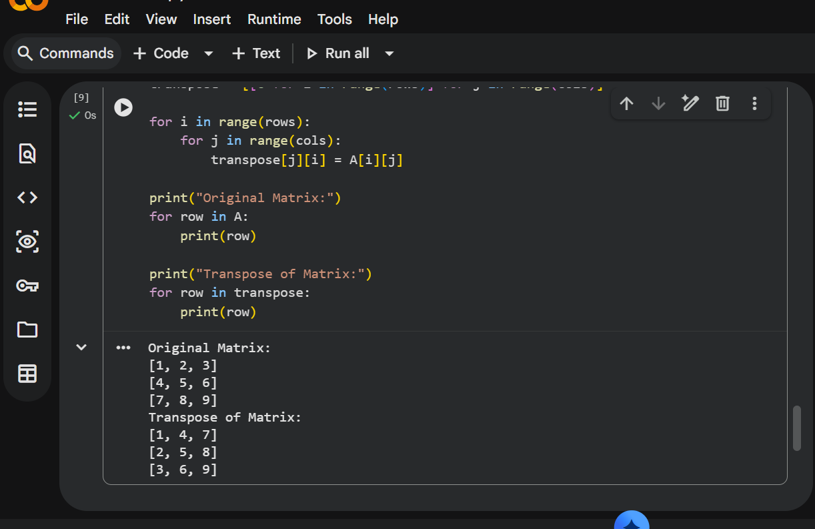

5. Result
Thus, the Python program to find the transpose of a matrix was executed successfully.

Experiment 4: Sort a Sentence in Alphabetical Order Using Python
1. Aim
To write a Python program to sort the words in a sentence in alphabetical order.
2. Algorithm
- Start the program.
- Initialize a sentence.
- Split the sentence into individual words.
- Sort the words in alphabetical order.
- Display the sorted sentence.
- Stop the program.
3. Python Code
# Sort a Sentence in Alphabetical Order
sentence = "banana apple mango orange grape"
words = sentence.split()
words.sort()
print("Original Sentence:", sentence)
print("Sorted Sentence:", " ".join(words))
4.output:
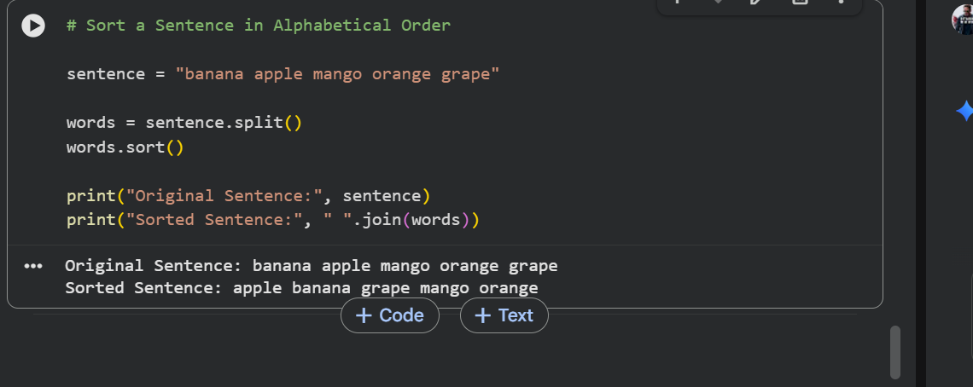
5. Result
Thus, the Python program to sort the words in a sentence in alphabetical order was executed successfully.

Experiment 5: List Operations Using Python
1. Aim
To write a Python program to implement list operations such as nested list, length, concatenation, membership, iteration, indexing, and slicing.
2. Algorithm
- Start the program and initialize two lists.
- Create and display a nested list.
- Find the length of the list using len().
- Perform concatenation and membership operations.
- Display list elements using iteration and indexing.
- Perform slicing and display the results.
3. Python Code
# List Operations in Python
list1 = [10, 20, 30, 40, 50]
list2 = [60, 70, 80]
# Nested List
nested_list = [list1, list2]
print("Nested List:", nested_list)
# Length
print("Length of List1:", len(list1))
# Concatenation
print("Concatenation:", list1 + list2)
# Membership
print("Is 30 in List1?", 30 in list1)
print("Is 90 in List1?", 90 in list1)
# Iteration
print("List Elements:")
for item in list1:
print(item)
# Indexing
print("Element at Index 2:", list1[2])
# Slicing
print("Elements from Index 1 to 3:", list1[1:4])
print("First Three Elements:", list1[:3])
4.output:
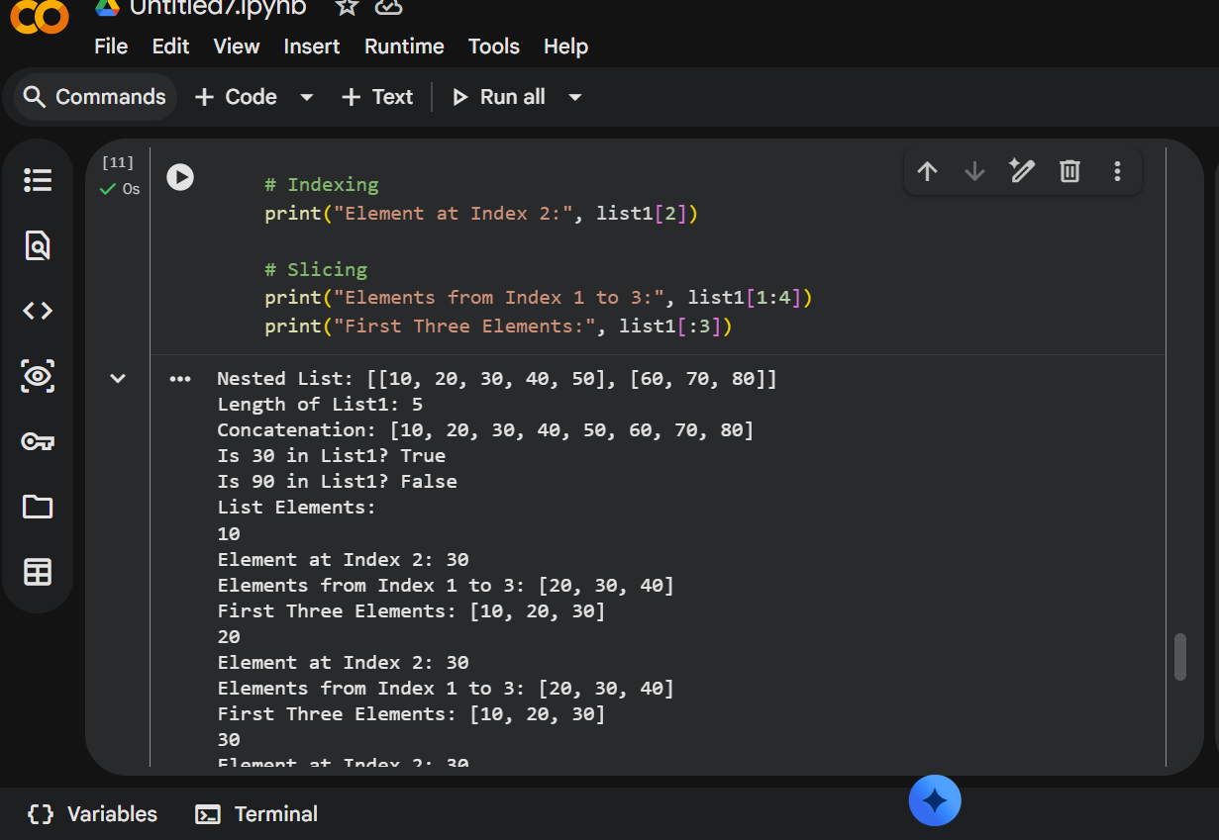

5. Result
Thus, the Python program to implement list operations was executed successfully.

